Guide to Downloading Submitted Application Forms and Supporting Documents

- Access the Portal
Go to the Single Access Portal of your National Patent Office using the following link on the SAP tool.

- Log In
Log in using your credentials.

- View Candidate Information
After logging in, you will see a list of candidates along with their personal details from the application form.

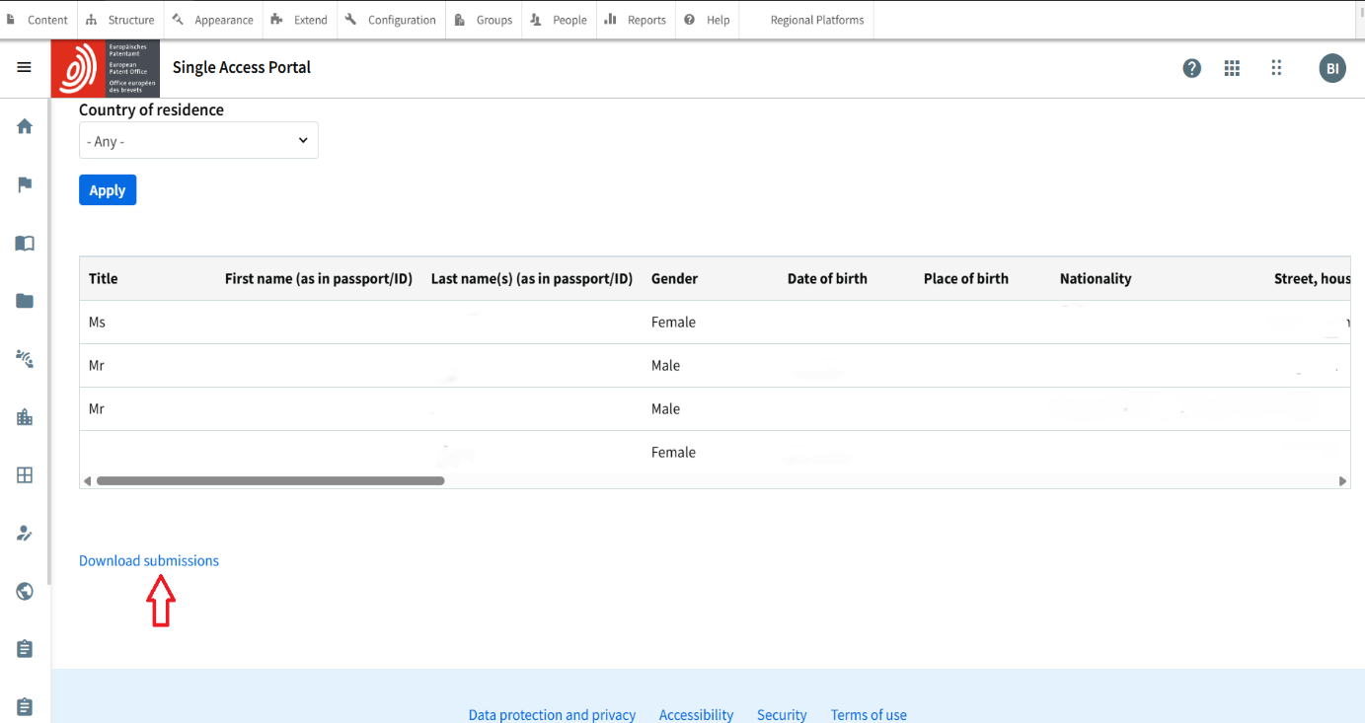

- Download Application Form
    - You can download the submitted candidate's application forms in pivot format as a CSV file.
    - To open it in Excel, save the CSV file and open it with Excel.

Note: The page will display candidate data only if submissions have been made.

- Download Supporting Documents
By scrolling to the far right of the table listing the personal details, you will find the documents submitted by each candidate. These must include:
    - Motivation Letter
    - CV
    - Proof of permanent residency

Click on the document name to download it in PDF format.

